- FRTB internal model based approach uses Expected shortfall metric to calculate regulatory market risk capital requirement for trading book.
- What are modellable risk factors ?
Answer: There is a risk factor eligibility test:
https://www.bis.org/basel_framework/chapter/MAR/31.htm?inforce=20230101&published=20200605#paragraph_MAR_31_20230101_31_1

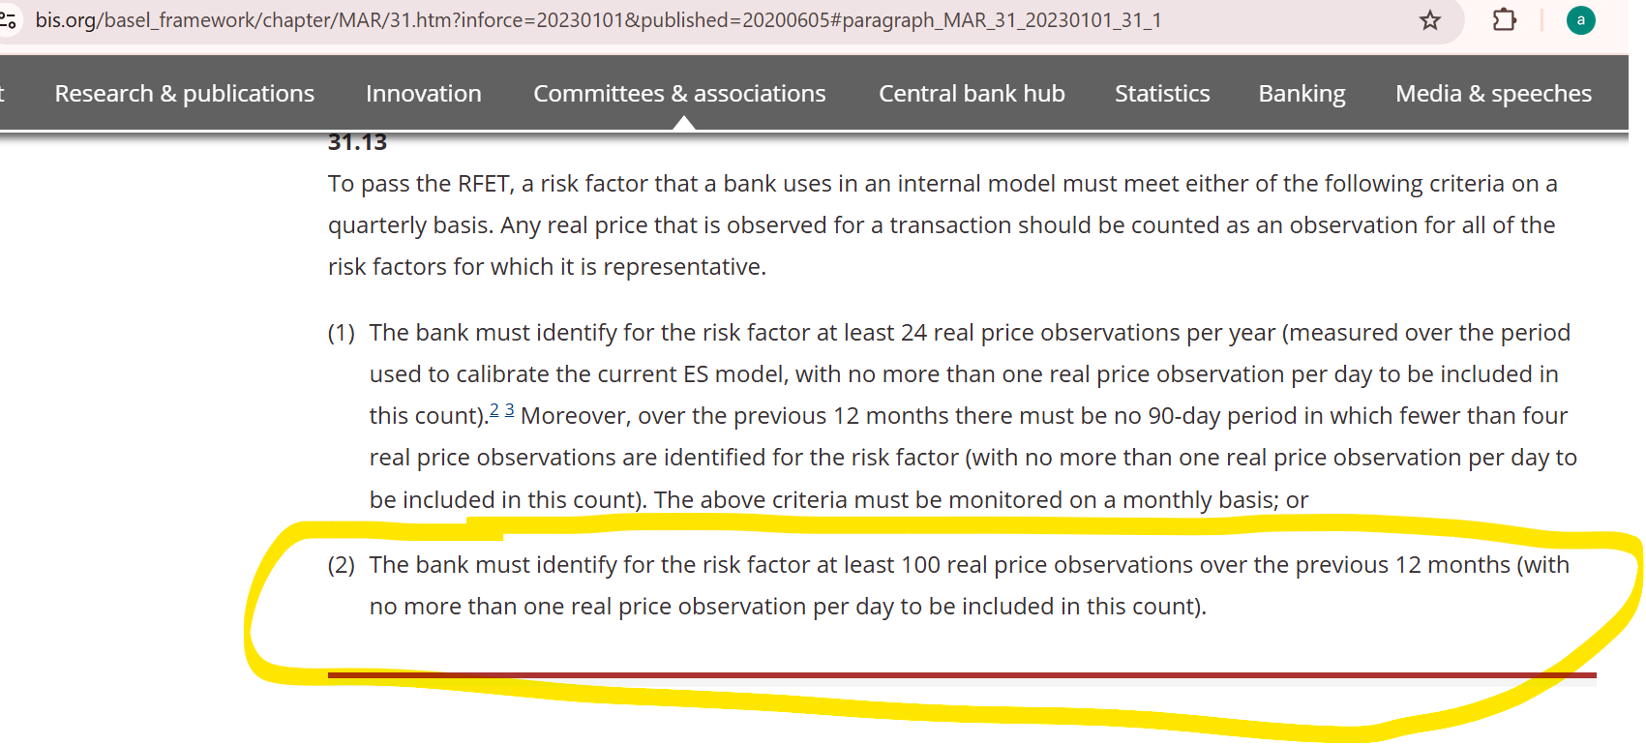
So if the bank has 100 real price observations over the previous 12 months then the risk factor passes the model lability test. The 2nd criteria above is dovish compared to criteria 1 and banks are most likely to choose criteria 2 for risk factor eligibility test.

- Frequency of ES calculations -daily at 97.5% one tailed confidence with base horizon of 10 days
- What does Liquidity horizon mean ?
LH means on an average Bank can liquidate or hedge the risk factor in this many days. That’s the reason highly liquid risk factors like rates and equities have lower LH.
- ES methodology: ES is calculated based on a methodology where risk factors of portfolio are divided on liquidity horizons and ES is calculated by keeping lowest liquidity horizon risk factors constant and using scenarios for only higher LH risk factors. Base horizon is 10 days. So we get ES for each liquidity horizon and higher LH ES is scaled to actual LH for that risk factor using square root rule.
- What are different applicable risk factors and their liquidity horizons:
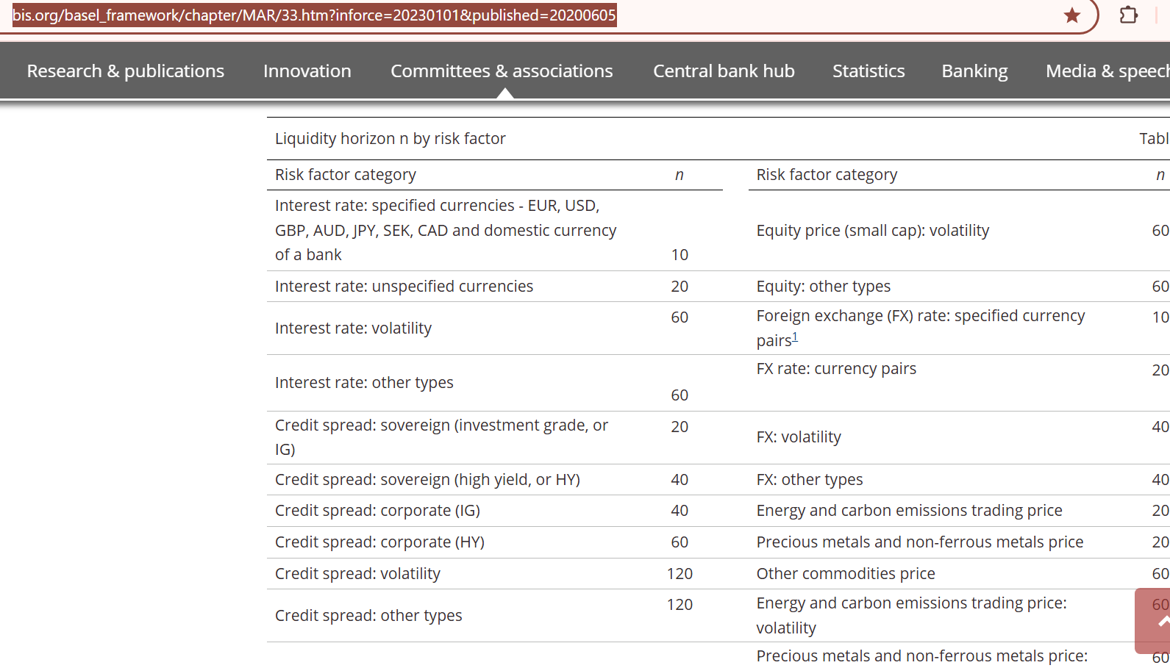
https://www.bis.org/basel_framework/chapter/MAR/33.htm?inforce=20230101&published=20200605

- Why Stressed ES is required:
Answer: ES must be calibrated to stressed period on which bank faced maximum losses. Risk factors applicable in historical stressed period period must be able to explain 75% of ES based on previous(current) risk factor scenarios. So $\frac{ES\left(Stressed\right)}{ES(Current)}$ > 75%
- There are many versions of ES required as below. I had to calculate all below 12 ES
Sr. No | ES | Diversified ? | All Risk classes ? | Risk factors(Current or Stressed period) ? | Full Risk factors or Reduced ?
1 | ES_{F,C} | Yes | All | Current | Full
2 | ES_{R,C} | Yes | All | Current | Reduced
3 | ES_{R,S} | Yes | All | Stressed | Reduced
4 | ES_{F,C} | No | Equity | Current | Full
5 | ES_{R,C} | No | Equity | Current | Reduced
6 | ES_{R,S} | No | Equity | Stressed | Reduced
7 | ES_{F,C} | No | Credit Spread | Current | Full
8 | ES_{R,C} | No | Credit Spread | Current | Reduced
9 | ES_{R,S} | No | Credit Spread | Stressed | Reduced
10 | ES_{F,C} | No | Interest rates | Current | Full
11 | ES_{R,C} | No | Interest rates | Current | Reduced
12 | ES_{R,S} | No | Interest rates | Stressed | Reduced

If there are more risk classes in portfolio then more ES would be required.
ES formula below:
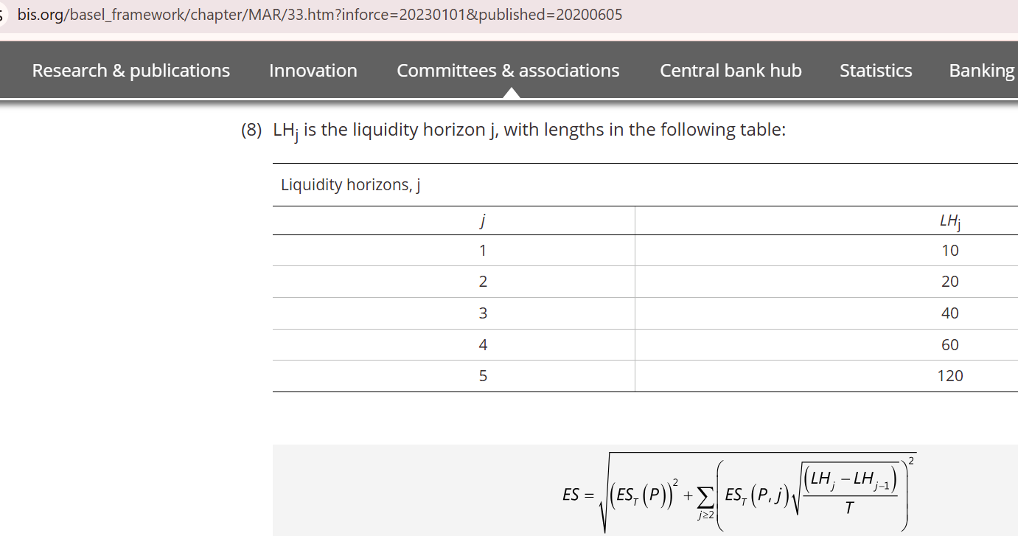

https://www.bis.org/basel_framework/chapter/MAR/33.htm?inforce=20230101&published=20200605

- Diversified ES formula: The circled ratio is floored to 1 so this cannot scale down ES.
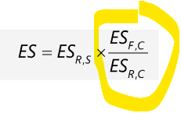

- Final trading book regulatory capital requirement: Final capital is calculated from full portfolio ES and risk class specific ES. Full portfolio ES is diversified ES because it incorporates all correlations. Risk class specific ES is undiversified ES. So basically we need diversified ES undiversified ES . Half portion of capital comes from diversified ES and half from diversified i.e. $ρ=0.5$
IMCC(C) = Diversified Internally modellable capital charge ES. This has to be calculated daily
IMCC(C_{i}) = Undiversified Internally modellable capital charge ES for broad risk classes. This can be calculated weekly. Ratio $\frac{IMCC(C)}{IMCC(All asset classes)}$ may not need to be calculated daily, so even a weekly calculation will do.
$$ρ=0.5$$
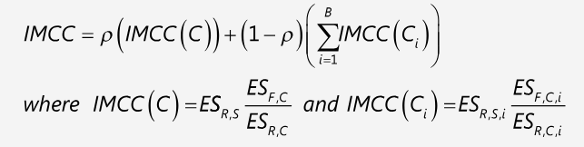
https://www.bis.org/basel_framework/chapter/MAR/33.htm?inforce=20230101&published=20200605

